EXP NO:10 DATE:17/10/24

# Ping to test server connectivity using sockets

Installing Python Ping pip install pythonping in windows python get-pythonping.py [in run command prompt] Python Ping (pythonping) is a public repository you can find on PyPI**.** from pythonping import ping ping('8.8.8.8') simply ping Google. you won’t see anything in your console if you just run this script. This is because our ping is silent by default, and does not print anything to screen.

If we want to see everything on-screen, we can simply use the verbose flag. ping('8.8.8.8', verbose=**True**)

Ping to test server connectivity

## How to ping a website in python

from os import system print('1. Ping Google') print('2. Ping Yahoo') print('3. Ping custom URL') while True:

key = int(input('Input your choice: ')) if key == 1:

system("ping [www.google.com](http://www.google.com/)") elif key == 2:

system("ping [www.yahoo.com](http://www.yahoo.com/)") elif key == 3:

url = input('Enter URL: ') system("ping " + url) else: print("Invalid Option!")

output:

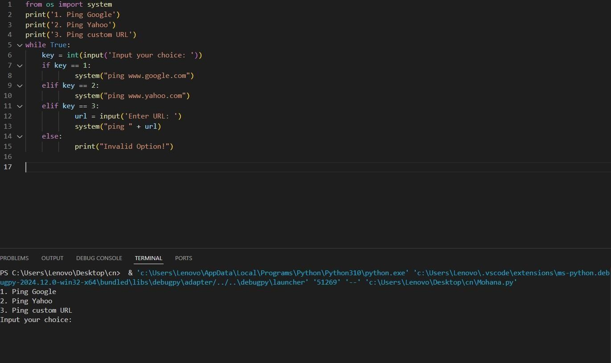

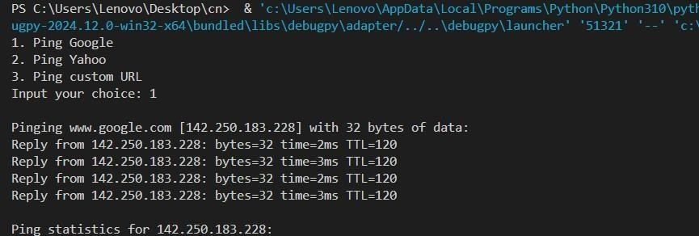

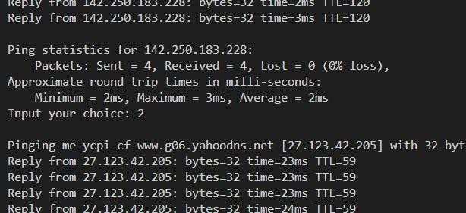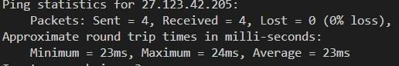

import os os.system("ping google.com")

import os

os.system('ping 127.0.0.1')

# EXP NO:10 DATE:17/10/24

**PING TO TEST SERVER CONNECTIVITY USING SOCKETS**

# AIM:

To develop ping program to test server connectivity using sockets.

# ALGORITHM:

**Server.py**

1. Import the socket package
2. Initialize local IP address and local port.
3. Create a socket using socket() function
4. Bind the IP address and port number.
5. Accept client request for connection. 6. Print the received connection details
6. Send reply message to the client.
7. Close the connection.

# Client.py

1. Import the socket package 2. Initialize server IP address and local port.

1. Create a socket using socket() function.
2. Start the timer.
3. Send message to the server.
4. The reply message of the server is received.
5. The timer is stopped.
6. Print the round trip time statistics.

**Ping to test server connectivity using sockets**

# Client code:

from socket import * from os import system s = socket(AF_INET, SOCK_STREAM)

s.connect(("127.0.0.1",8000)) # Connect op='connect'

s.send(op.encode('utf-8')) # Send request data = s.recv(100).decode()# Get response print(data) system("ping "+ gethostname()) s.close()

**#Server Code:** from socket import * from os import system s = socket(AF_INET,SOCK_STREAM)

s.bind(("",8000))

s.listen(5) while True:

c,a = s.accept()

print("Received connection from", a) data=c.recv(100).decode() print(data) c.send(data.encode('utf-8'))

system("ping "+ a) c.close()

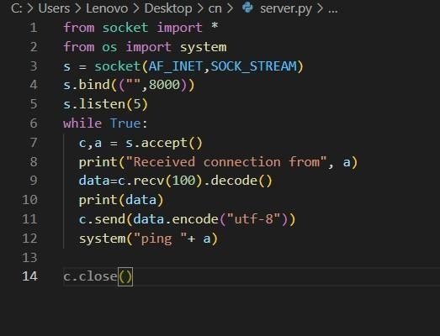output: server:



Client:

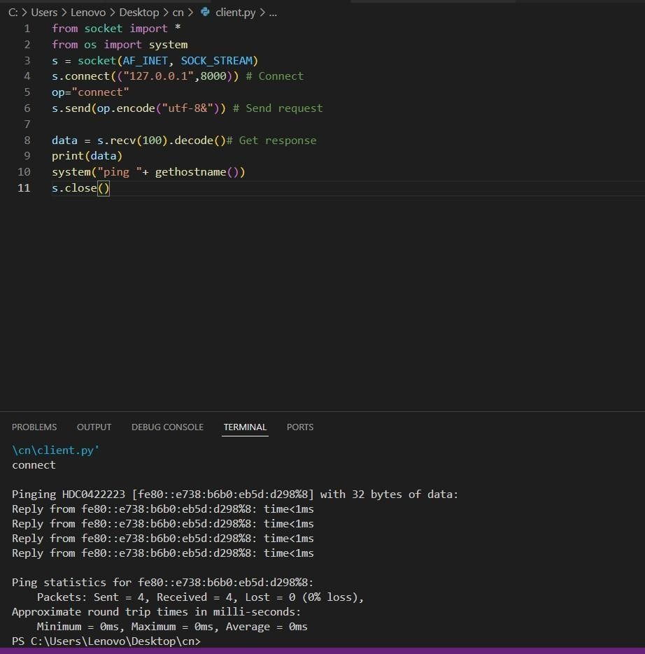

## Result:

Server connectivity is tested using python program.